A
PROJECT PHASE I REPORT
On

PROJECT TITLE

Submitted to
MIT Art, Design & Technology University
in partial fulfilment of the requirements for the award of the degree of
BACHELOR OF TECHNOLOGY
IN
ELECTRONICS AND COMMUNICATION ENGINEERING

Submitted by
Group Code: …………………
SAMARTH KIWADE MITU21MTMD0003
ABHIJIT PATIL MITU21MTMD0004
MRUNAL DOKE MITU21…………….

Under the Guidance of
Prof. Dr. (Guide Name)



DEPARTMENT OF ELECTRONICS AND COMMUNICATION ENGINEERING
MIT SCHOOL OF ENGINEERING AND SCIENCES,
MIT ADT UNIVERSITY RAJBAUG, LONI KALBHOR, PUNE – 412201
NOVEMBER 2025

DEPARTMENT OF ELCTRONICS AND COMMUNICATION ENGINEERING
SCHOOL OF ENGINEERING AND SCIENCES,
MIT ADT UNIVERSITY, RAJBAUG, LONI KALBHOR,
PUNE – 412201

CERTIFICATE

This is to certify that the Project Phase I (21BTCO721R) report entitled
“PROJECT TITLE”

Submitted by

SAMARTH KIWADE MITU21MTMD0003
ABHIJIT PATIL MITU21MTMD0004
MRUNAL DOKE MITU21…………….

is a bonafide work carried out by them, under the supervision of Prof. Dr. (Guide Name) and it is submitted towards the partial fulfilment of the requirement of MIT Art, Design and Technological University, Pune for the award of the Bachelor of Technology in Electronics and Communication Engineering.

Prof.  Guide | Prof. Poonam B. Dhole  Project Co-ordinator
Prof. Dr. Sachin Takale  Program Head ,ECO | Prof. Dr. Gopal S. Gawande  Head of Department, ECE
Prof. Dr. Sudarshan B. Sanap  Dean, Faculty of Engineering and Sciences | Chairperson / Examiner

Place: Pune
Date: 24/11/2025
DECLARATION
We hereby declare that the project entitled “Project Title” submitted towards the partial fulfilment of the requirement of MIT-ADT University, Pune for the award of the Bachelor of Technology in Electronics and Communication Engineering, is a record of bonafide work carried out by us under the supervision of Prof. (Guide Name) ______________, Department of Electronics and Communication Engineering, School of Engineering and Sciences.
We further declare that the work reported in this report has not been submitted, and will not be submitted, either in part or in full, for the award of any other degree or diploma in this institute or any other institute or university.

Place: Student Names and Sign
Date:

( Insert table and hide the borders )

SPONSORSHIP LETTER (if any)

ACKNOWLEDGEMENT

We express our profound thanks to our Guide Name of Guide, Electronics and Communication Engineering, School of Engineering and Sciences MIT-ADT University, Pune for his/her expert guidance, encouragement and inspiration during this Project Phase I work.
We are very thankful to Prof. Poonam B Dhole, UG Project Co-ordinator, Electronics and Communication Engineering Department for her guidance and all kinds of help to complete my/our work.
We sincerely appreciate to Prof. Mahesh A. Kamthe, PBA Co-ordinator, Electronics and Communication Engineering Department for his guidance and all kinds of help to complete my/our work.
We also express thanks to Prof. Dr. Sachin Takale, Program Head, Electronics and Computer Engineering Prof. Dr. Gopal S. Gawande, Head, Department of Electronics and Communication Engineering, for being constant source of inspiration throughout the execution.
We are grateful to Prof. Dr. Sudarshan B. Sanap, Dean, Faculty of Engineering and Sciences, MIT-ADT University, Pune, for providing us the facilities to carry out this work.
We also thank all the faculty members in the department for their support and advice. We are very much grateful to our Parents for their immense love, affection, help, cooperation and encouragement to complete this course.
Finally, we extend our heartfelt thanks to all our classmates and friends for their constant support, guidance, and encouragement throughout the successful completion of our Project Phase I.
Student Names

ABSTRACT
Abstract should be one page synopsis of the report typed one and a half line spacing, Font Style: Times New Roman and Font Size: 12. The abstract is a very brief summary
of the work contents. It should be about one page long not more than 300 words. The 300-word statement should describe the problem addressed by your work, a description
of the work completed and a summary of any findings or lessons learned.

PHOTOGRAPH OF THE PROJECT
- The students should include the colour photo of the project
- For experimental/Fabrication/Development work include the actual photo with a clear background
- For study based/Numerical/Analytical/Conceptual work include the photo of key results which represents the key component of the project
- The image should be greater than 300 dpi and must be included in a single page only.

TABLE OF CONTENTS

ABSTRACT i
PHOTOGRAPH OF THE PROJECT ii
TABLE OF CONTENTS iii
LIST OF FIGURES iv
LIST OF TABLES iv
ABBREVIATIONS v
Chapter 1 1
INTRODUCTION 1
1.1 Introduction 1
1.2 Guidelines for Introduction 1
1.3 Organization of the Report 2
1.4 Closure 2
Chapter 2 3
LITERATURE REVIEW 3
2.1 Introduction 3
2.2. Review of literature 3
2.4 Summary of the literature 4
2.4 Identification of Gaps/Scopes of Work 4
2.5 Problem Statement 4
2.6 Objectives 4
2.7 Closure 4
Chapter 3 5
METHODOLOGY 5
3.3 Block Diagram 5
3.4 Closure 5
CHAPTER 4 6
RESULTS AND DISCUSSIONS 6
4.1 Introduction 6
4.2 Key points in Results and Discussion 6
CHAPTER 5 7
CONCLUSION AND FUTURE SCOPE 7
5.1 Conclusion 7
5.2 Future Scope 7
APPENDIX I 9
COST SHEET 9
APPENDIX II 10
PROJECT BASED AWARDS AND ACHIEVEMENTS (if any) 10
PATENT 10
COPY RIGHT 10
LIST OF PUBLICATIONS 10
AWARDS/ACHIEVEMENT IN ANY COMPETITIONS 10
APPENDIX III 11
PROJECT BASED OUTCOMES 11

LIST OF FIGURES
Fig. No. | Name of the Figure | Page No.

LIST OF TABLES
Table No. | Name of the Table | Page No.

ABBREVIATIONS
All abbreviations used in the entire report must appear in this section in Alphabetical order
The representative given in below figure is only for understanding of students.
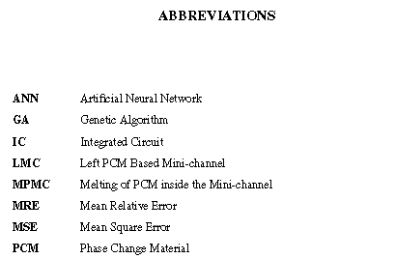

Chapter 1

INTRODUCTION

Introduction
Each Chapter should begin with the introduction. It must include a brief introduction of the chapter.

Guidelines for Introduction
- Start broadly and then narrow down
- State the aims and importance
- Cite thoroughly but not excessively
- Avoid giving too many citations for one point
- Clearly state either your hypothesis or research question
- Consider giving an overview of the report
- Keep it short
- Don't bury your readers in detail

The representative given in below figure is only for understanding of students.
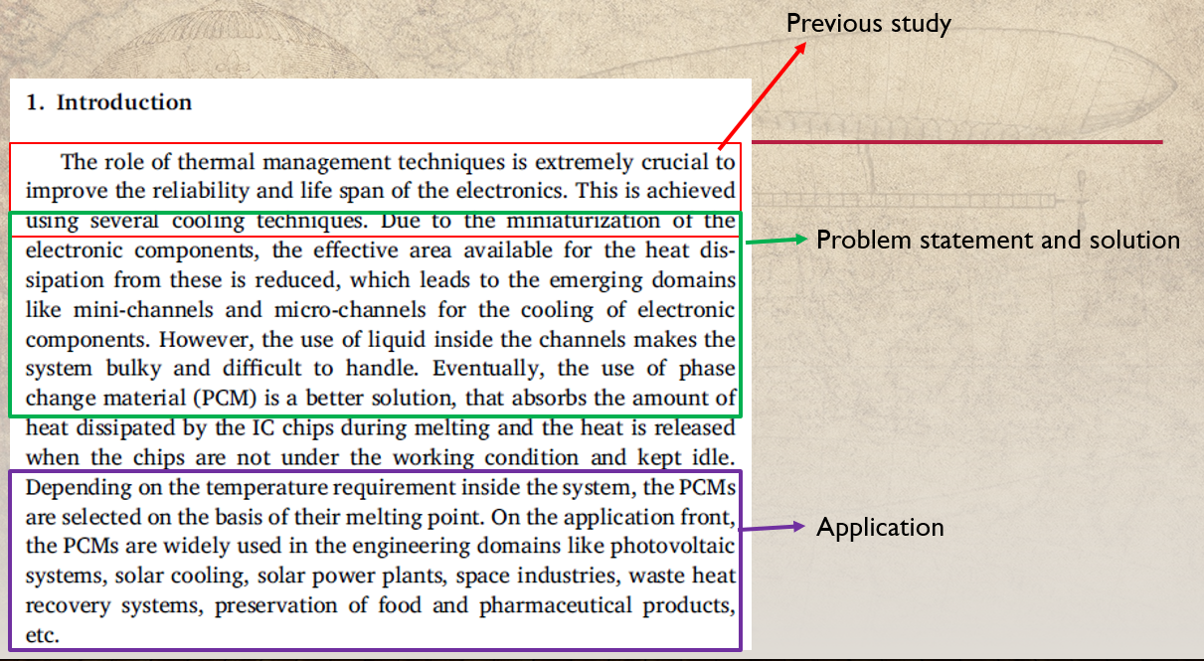
Fig. 1.1 Guidelines for Introduction

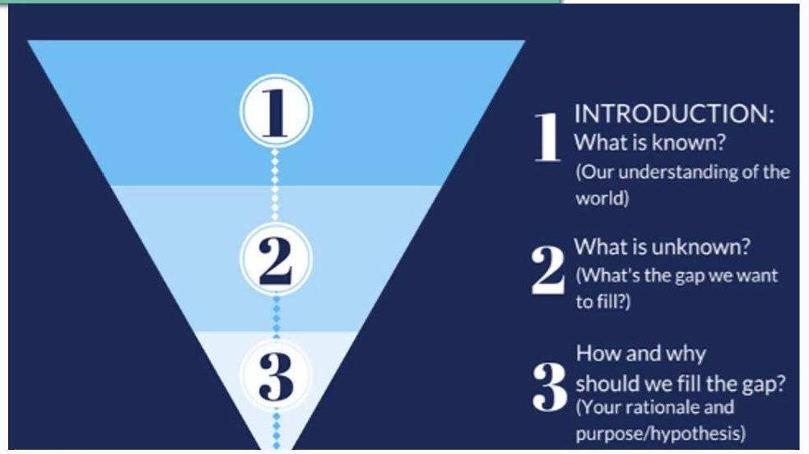
Fig. 1. 2 Top approach of Introduction

1.3 Organization of the Report
In this subheading the details of each chapter must be included with a brief introduction which gives a detail overview of the mini-project/project/thesis. The below context is to give an idea to the reader.
Chapter 1 includes the introduction to the concerned topic and the need for specified research.
Chapter 2 provide a detailed literature review of the research topic and summaries the literature followed by research gap. It also formulates the objective for the present study.
Chapter 3 discusses the experimental methodology carried out in the present study.
Chapter 4 presents the results of work done with discussions on results.
Chapter 5 states conclusion and future scope.

Closure
Each Chapter should conclude with the closure providing brief output of the chapter and should include a trailer of the next chapter with its introduction.

Chapter 2

LITERATURE REVIEW

2.1 Introduction
This chapter elucidates the complete review of the literature pertinent to the present
study. For easy understanding, the literature review has the following subsections

2.2. Review of literature
Karvinkoppa and Hotta [1] discussed a literature review is a text of a scholarly paper, which includes the current knowledge including substantive findings, as well as theoretical and methodological contributions to a particular topic. Literature reviews are secondary sources, and do not report new or original experimental work. Most often associated with academic-oriented literature, such reviews are found in academic journals, and are not to be confused with book reviews that may also appear in the same publication. Literature reviews are a basis for research in nearly every academic field Maedche and Staab [2]. A narrow-scope literature review may be included as part of a peer-reviewed journal article presenting new research, serving to situate the current study within the body of the relevant literature and to provide context for the reader. In such a case, the review usually precedes the methodology and results sections of the work.
Mathew and Hotta [3] producing a literature review may also be part of graduate and post-graduate student work, including in the preparation of a thesis, dissertation, or a journal article. Literature reviews are also common in a research proposal or prospectus (the document that is approved before a student formally begins a dissertation or thesis) Karvinkoppa and Hotta [4]

2.3 Summary of the literature
Summarize the
    - Methodologies
    - Parameters
    - Key Findings

2.4 Identification of Gaps/Scopes of Work
    - Find the missing parameters and significance
    - Suggest the new methodology to address the above missing parameter
    - Recommend improvement in existing parameters/methods

2.5 Problem Statement
    - It must be described in 2 to 3 lines.
    - Do not describe the method
    - Do not describe in detail
    - Only the key component must be highlighted

2.6 Objectives
    - Objective must be breakup of problem statement
    - Describe your objectives in short sentences not paragraph
    - It should be around three to four objectives

2.7 Closure
Each Chapter should conclude with the closure providing brief output of the chapter and should include a trailer of the next chapter with its introduction.

Chapter 3

METHODOLOGY
3.1 Introduction
The author should introduce in brief the methodology carried out for the project work.
3.2 Methodology details
The methodology of the project work can be of analytical/numerical/experimental either one or the combinations of any method. The students are expected to write in details the process of the project carried out. The example of the methodology is given in table 3.1. A reader must be able to reproduce your experimental, theoretical, computational, and simulations procedure based on the information presented in the report. The material presented in the report must be self-contained.

3.3 Block Diagram
You must include the block diagram and its description in this topic

3.4 Closure
Each Chapter should conclude with the closure providing brief output of the chapter and should include a trailer of the next chapter with its introduction.

CHAPTER 4

RESULTS AND DISCUSSIONS

4.1 Introduction
The following sections describe how your report should be formatted according to standard guidelines. The results must be described in quantitative manner rather than a vague explanation.

4.2 Key points in Results and Discussion
- Report the results in more logical way
- Only the findings of your study
- Focus on results that are most relevant to your research objectives
- Data presented in Figures, tables, charts, graphs etc.
- A contextual analysis of the data
- Explanation of the data derived from previous studies
- Error bars, statistical details
- Discuss weaknesses and discrepancies
- Explain what is new without exaggerating
- Do not repeat discussion/Fig/Tables or speculate too much

CHAPTER 5

CONCLUSION AND FUTURE SCOPE

5.1 Conclusion
This section will need to have brief summary, just a paragraph, of your key findings, results of the project work.

5.2 Future Scope
Each Chapter should conclude with the closure providing brief output of the chapter and should include a trailer of the next chapter with its introduction.

REFERENCES
[1] | Aryan Pillai, Neel Baladkar, Rishabh Kalro, Prof. Dr. Sachin Takale, “ Lithium-ion Battery Life Cycle Prediction System”, International Journal of Research and Analytical Reviews, Vol. 10, Issue 2, May 2023 e-ISSN 2348-1269
[2]
[3]
[4]
[5]
[6]
[7]
[8]
[9]
[10]

Web References
[1] | www.electronicsforyou.com

APPENDIX I

COST SHEET
Sr. No. | Particular | Amount (Rs.)
Total

APPENDIX II

PROJECT BASED AWARDS AND ACHIEVEMENTS (if any)
The student need to attach the testimonials of the achievement obtained for the project work at the end of the Appendix II.

PATENT
The students need to write the patent details and attach the testimonial for the same (if any). Write NIL if didn’t apply.

COPY RIGHT
The students need to write the copyright details and attach the testimonial for the same (if any). Write NIL if didn’t apply.

LIST OF PUBLICATIONS
The students need to write the publications details in IEEE format and attach the entire paper in the final report for the same (if any). Write NIL if didn’t publish.

AWARDS/ACHIEVEMENT IN ANY COMPETITIONS
The students need to write the details of any awards/achievement received relevant to the project work along with the photograph (if any). Write NIL if didn’t participate.

APPENDIX III

PROJECT BASED OUTCOMES
The student need to fill the below table for the outcomes they have gained during the work. These outcomes will vary based on Project Based Learnings.
Outcomes | Agree  (1) | Moderately  (2) | Highly Agree (3)
1. Engineering knowledge: Apply the knowledge of mathematics science engineering fundamentals and a mathematics, science, engineering fundamentals, and an engineering specialization to the solution of complex engineering problems engineering problems.
2. Problem analysis: Identify, formulate, review research literature, and analyse complex engineering problems reaching substantiated conclusions using first principles of mathematics, natural sciences, and engineering sciences.
3. Design/development of solutions: Design solutions for complex engineering problems and design system components or processes that meet the specified needs with appropriate consideration for the public health and safety, and the cultural, societal, and environmental considerations
4. Conduct investigations of complex problems: Use research-based knowledge and research methods including design of experiments, analysis and interpretation of data, and synthesis of the information to provide valid conclusions
5. Modern tool usage: Create, , select, and apply appropriate techniques, resources, and modern engineering and IT tools including and modelling to complex engineering activities with an understanding of the limitations
6. The engineer and society: Apply reasoning informed by Apply reasoning informed by the contextual knowledge to assess societal, health, safety, legal and cultural issues and the consequent responsibilities legal and cultural issues and the consequent responsibilities relevant to the professional engineering practice
7. Environment and sustainability: Understand the impact of the professional engineering solutions in societal and environmental contexts, and demonstrate the knowledge of, and need for sustainable development and need for sustainable development.
8. Ethics: Apply ethical principles and commit to professional ethics and responsibilities and norms of the engineering practice
9. Individual and team work: Function effectively as an individual and as a member or leader in diverse teams and individual, and as a member or leader in diverse teams, and in multidisciplinary settings
10. Communication: Communicate effectively on complex engineering activities with the engineering community and with society at large, such as, being able to comprehend and write effective reports and design documentation, and write effective reports and design documentation, make effective presentations, and give and receive clear instructions
11. Project management and finance: Demonstrate knowledge and understanding of the engineering and knowledge and understanding of the engineering and management principles and apply these to one’s own work, as a member and leader in a team, to manage projects and in multidisciplinary environments.
12. Life-long learning: Recognize the need for and have the Recognize the need for, and have the preparation and ability to engage in independent and lifelong learning in the broadest context of technological change

